Illinois Coalition Team Led by Rahab’s Daughters Impact on Anti Trafficking at Superbowl LI

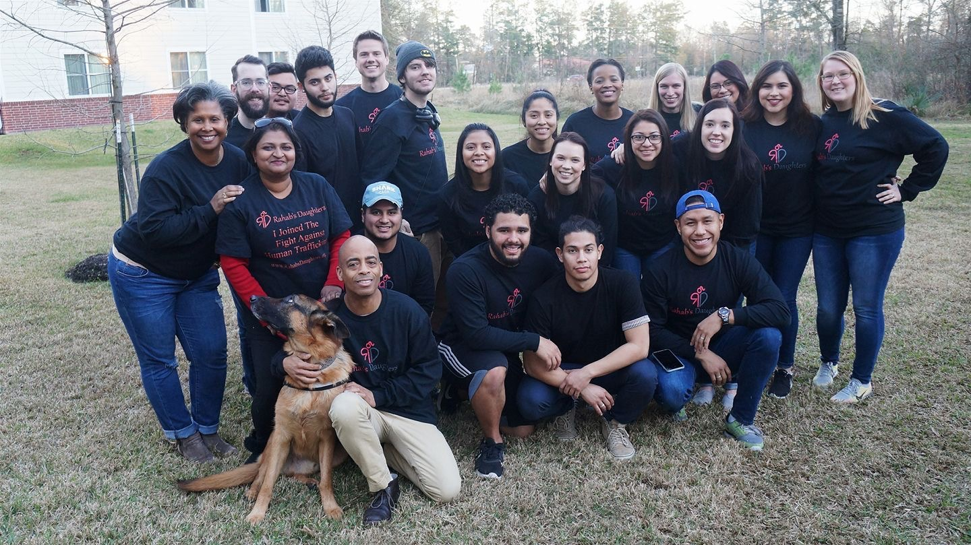

Every year for the past 4 years we have been heading to the city-hosting Super bowl with a coalition team of 20-30 adults aged 18-50 from Illinois to spread awareness, do outreach and provide for survivors of Human trafficking and this year was no different.

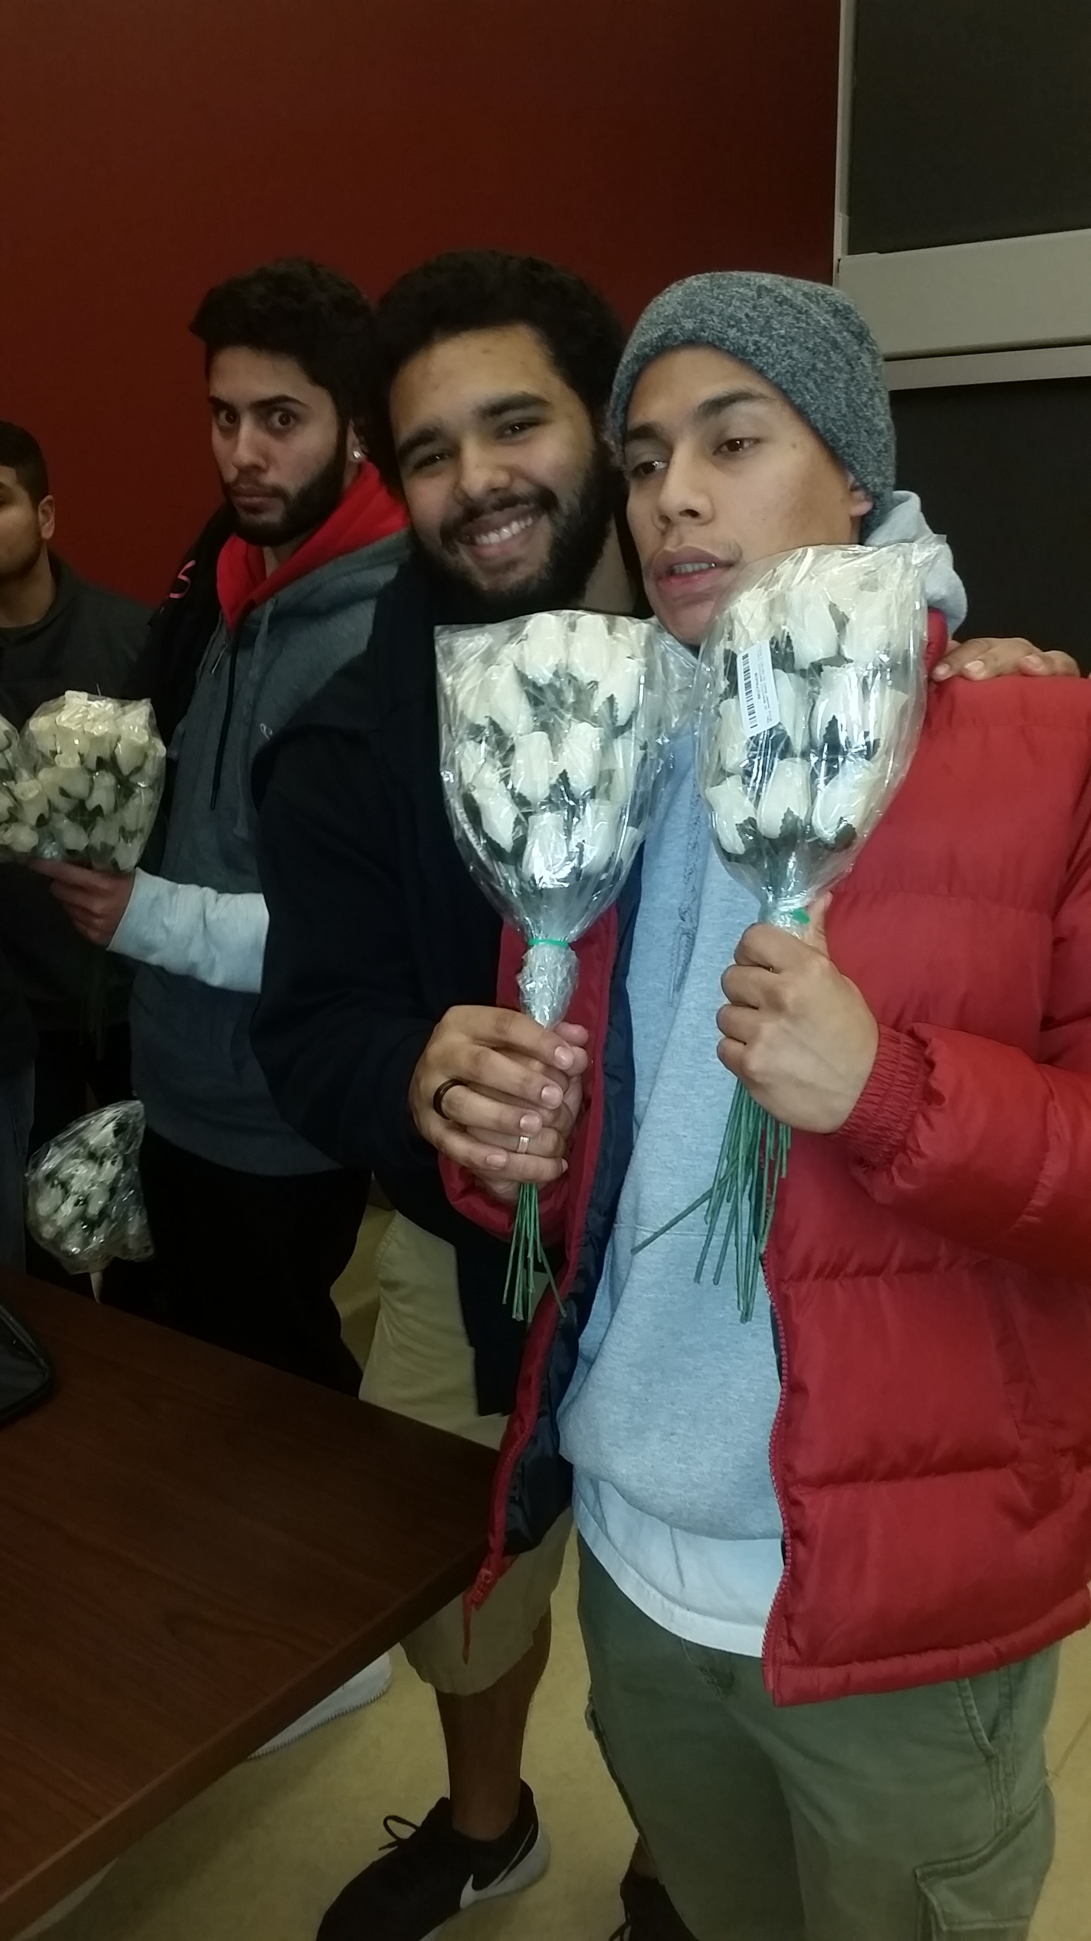
Our team Lead by Rahab’s Daughters Human Trafficking Survivor Sharmila Wijeyakumar, included volunteers from Willow Creek Community Church, The Chicago Masters Commission and New Covenant Life Church, spent time on a variety of activities in Houston From Jan 28th until Feb 6th.

Our Week started by tying Outreach Cards to 1008 Wooden Roses, and stapling them to 800 gift bags of Candy as we mapped a route to visit 472 Brothels in the Houston City and suburbs. We ended up over the Week Passing out 800 gift bags of candy 1008 Wooden roses 1000 live carnations and 2500 Wooden Bricks of Love which we left all over the streets of Houston with our hotline Number on it and asked people if they saw anything to say something to help.

Our team worked around the clock in shifts for 9 days and each male or female who was approached or came to us in the clubs, brothels or one the streets knew that we were there to let them know that someone cared about them. We did not stop there, we were bold enough to asked if they wanted us to help them break free. Many were afraid to come or even respond, as their pimps were not very far away.
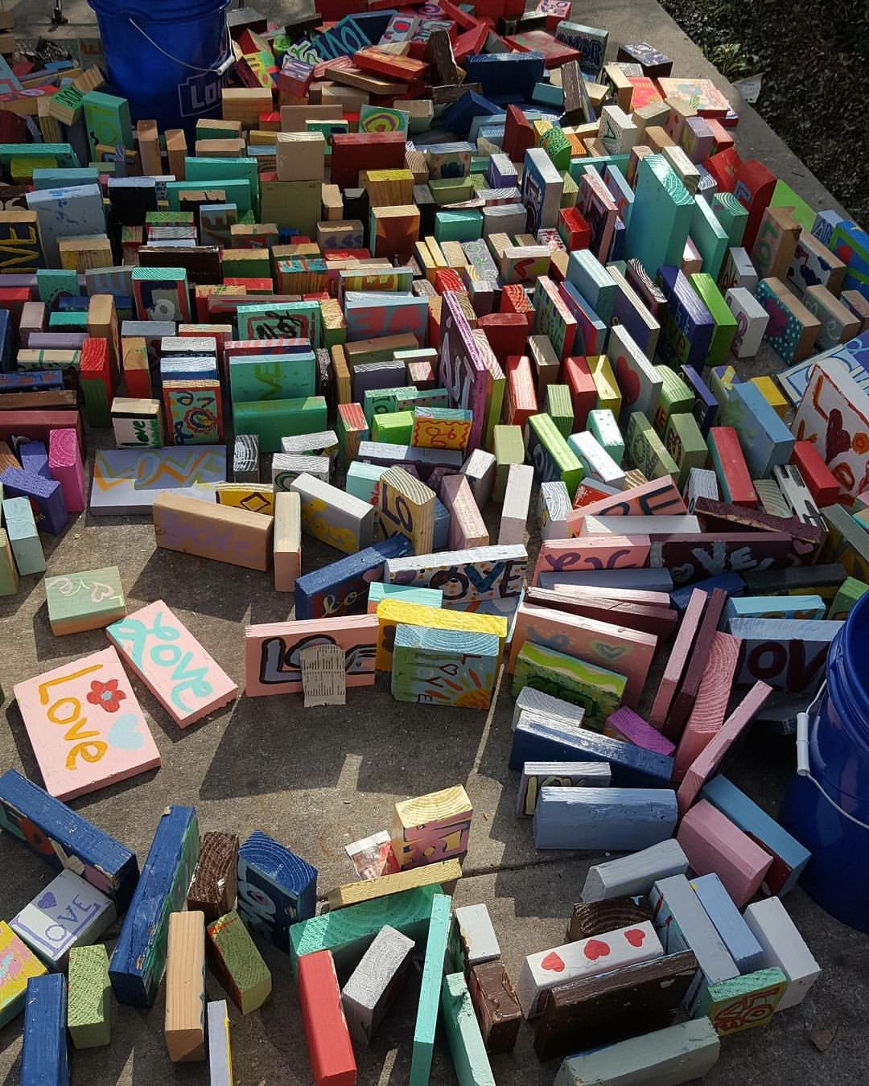
We worked the streets until the early mornings. Not all brothels and clubs were pleased to have us visit. We asked if they would give the gifts and roses to their girls, most agreed. We gave gift bags to the parking guys, who in turn allowed us to pass out roses to the dancers as they were walking in the parking lot or out for a smoke. The streets however were a different scene as there were times when we were encircled by the pimp and his crew as a intimidation tactic. We always give respect and avoid conflict. We were able to give a gift bag to a pimp on one occasion.

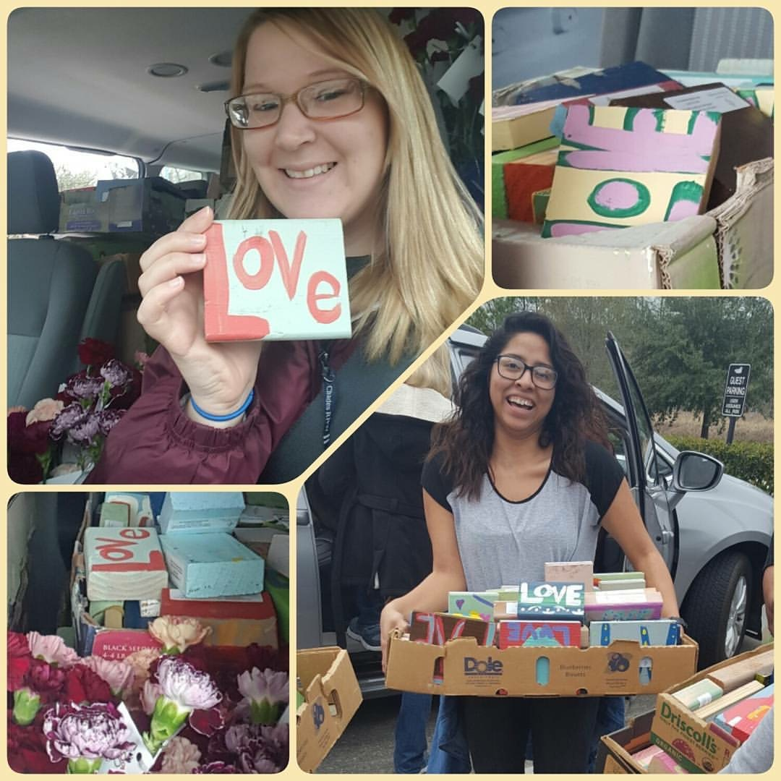
The Saturday before Super Bowl our team went through out Houston and place wooden blocks, with each uniquely painted with the word ‘love’ with out contact information. These blocks were placed to the side but visible by those walking through the communities. As a result, the community noticed the blocks and shared their support on our webpage. One person even called our hotline to report a girl being beaten by her pimp. With the details we were given we were able to pass this on to law enforcement and she was rescued along with another 17 year old also being trafficked by the same abusive Pimp.

We ended Super Bowl weekend with 5 female survivors who now have an opportunity of a fresh start; we have placed them all in drug rehab centers, as all of them were addicted to either Heroine or Crystal Meth. We have partnerships with providers all over the country and upon release from rehab with the help of local partners in Houston we will transport these women to safe houses and help them to start over.

This year we also took one of our 7 Service animals Milo with us to provide emotional support for the rescues and it was a very positive experience Milo helped to make the survivors feel safe and helped them to relax and open up more. One of the survivors Debbie wanted him to stay with her all the way through rehab but we explained she could see him again afterwards.

One of the key things we saw this year was the marked increase in Males being trafficked and we have decided to open our doors to Male survivors for the 1st time as a result of this one of our IL safe houses will be for Boys. The average age of the males we saw were 10-16 but we were unsuccessful in gaining their trust. Here in IL we will launch a new imitative this month to do male outreach starting Feb 17th.

One of our main takeaways from this year was the fact that we are seeing more and more drug use as a means of control and also more women with children fathered by the pimp as a form of control we met many women on the streets who wanted out but could not leave with us due to fear for the lives of their children. More homes like ours in IL need to allow Women and their children. Three of the five survivors we rescued have children under the age of 5.

